**2) Check out process in e-commerce web site.**

**Adding items to cart.**

Adding the products into cart by selecting and click on add to cart.

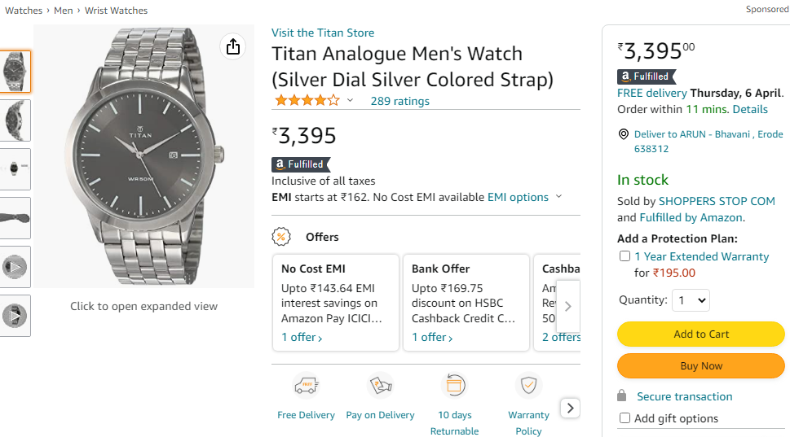

**Adding/Selecting shipping address.**

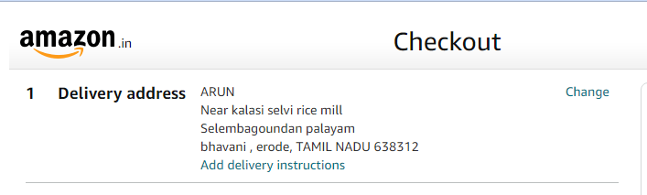

Selecting the product shipping address regarding needs.

**Entering payment details.**

Selecting and entering payment details of the order**.**

